KSR INSTITUTE FOR ENGINEERING AND TECHNOLOGY

TIRUCHENGODE

FULL STACK DEVELOPMENT

**NAME : SHOBNA SAMUKTHA RAJ S**

**DEPT : B.E-(CSE)**

**YEAR : IV**

**DATE : 06.08.2024**

**1.INSERTION IN INVENTORY MANAGEMENT SYSTEM :**

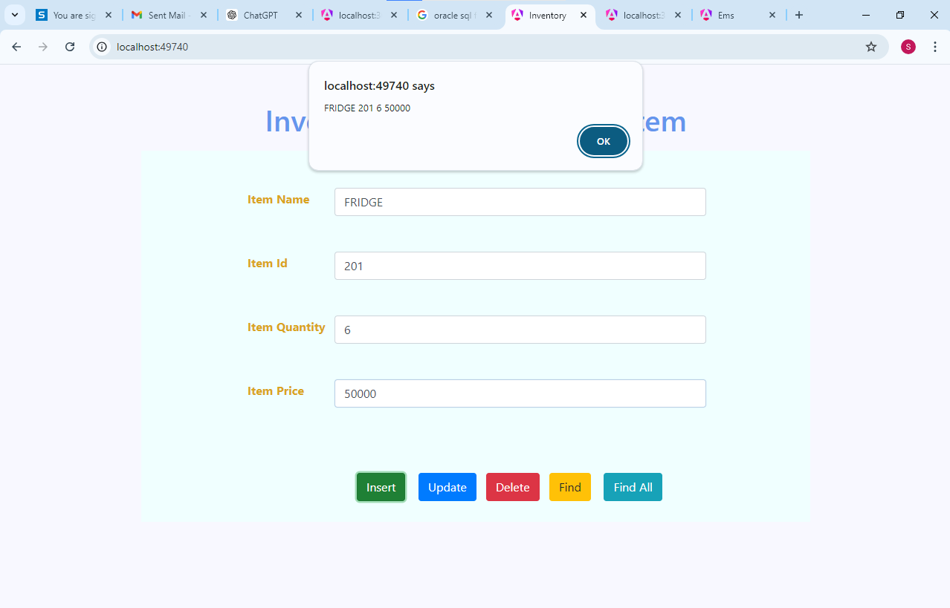

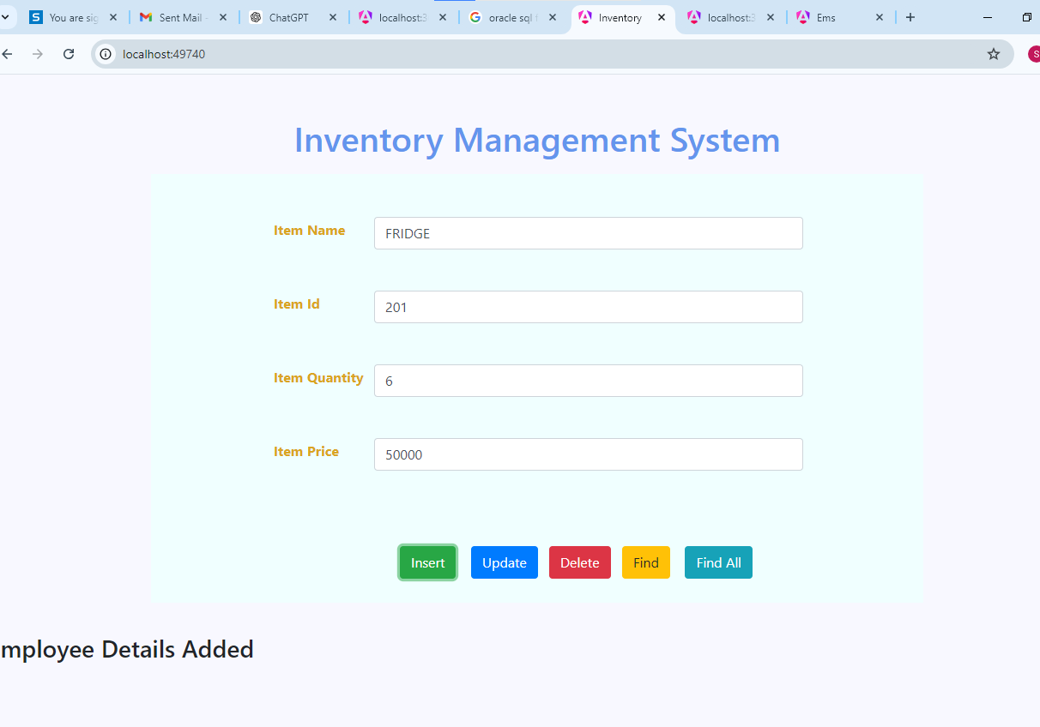

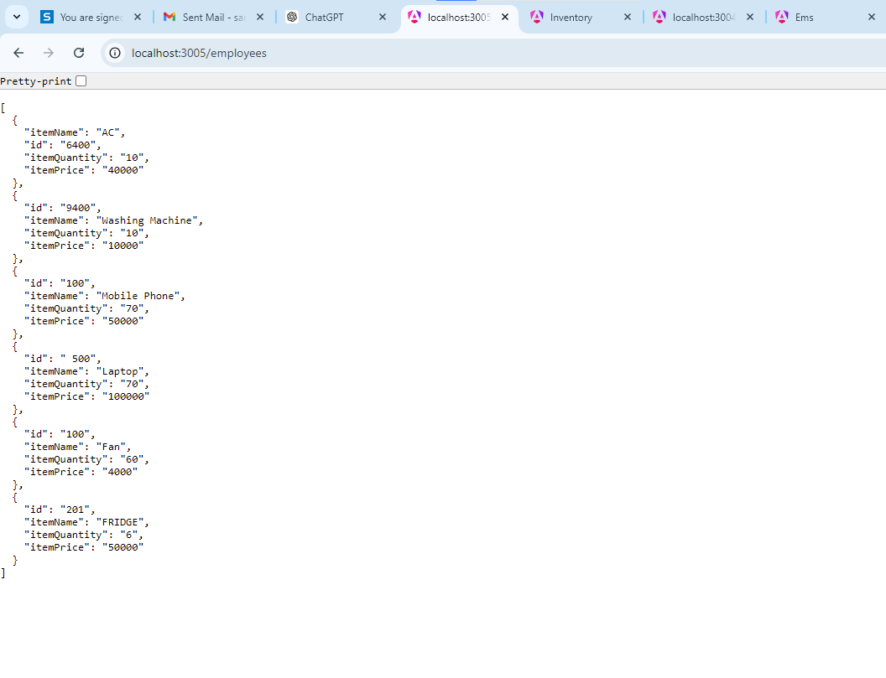

**2. UPDATION IN INVENTORY MANAGEMENT SYSTEM**

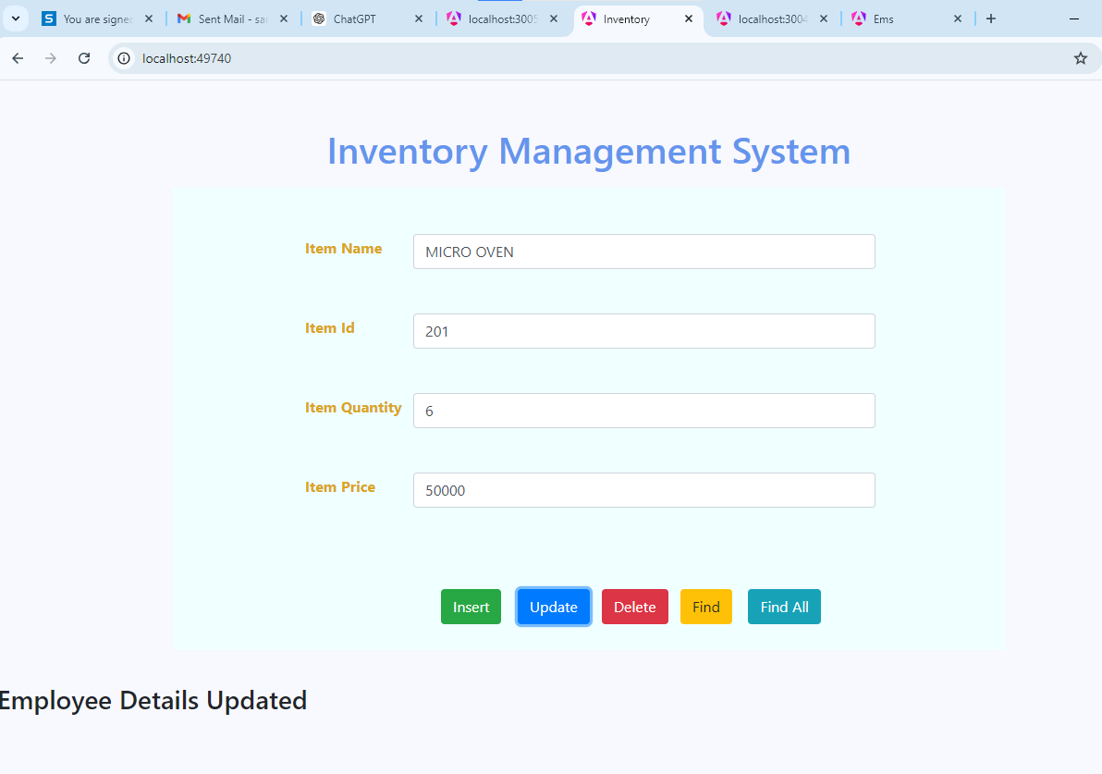

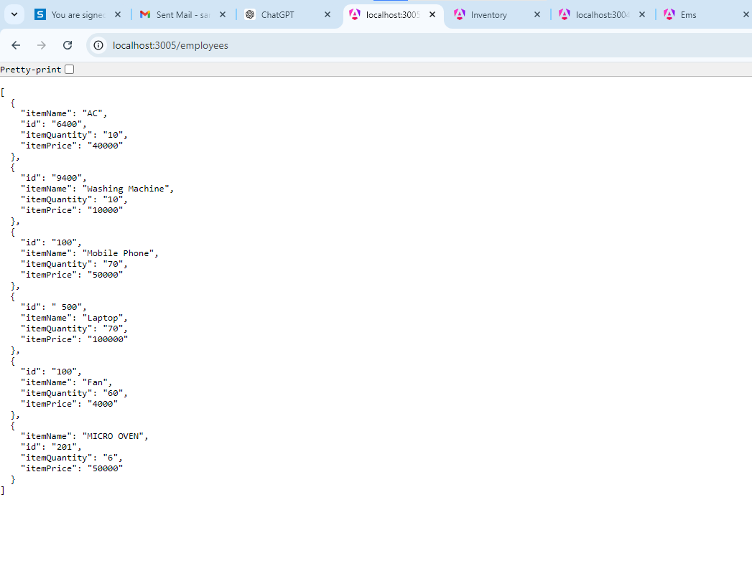

**3. DELETION IN INVENTORY MANAGEMENT SYSTEM .**

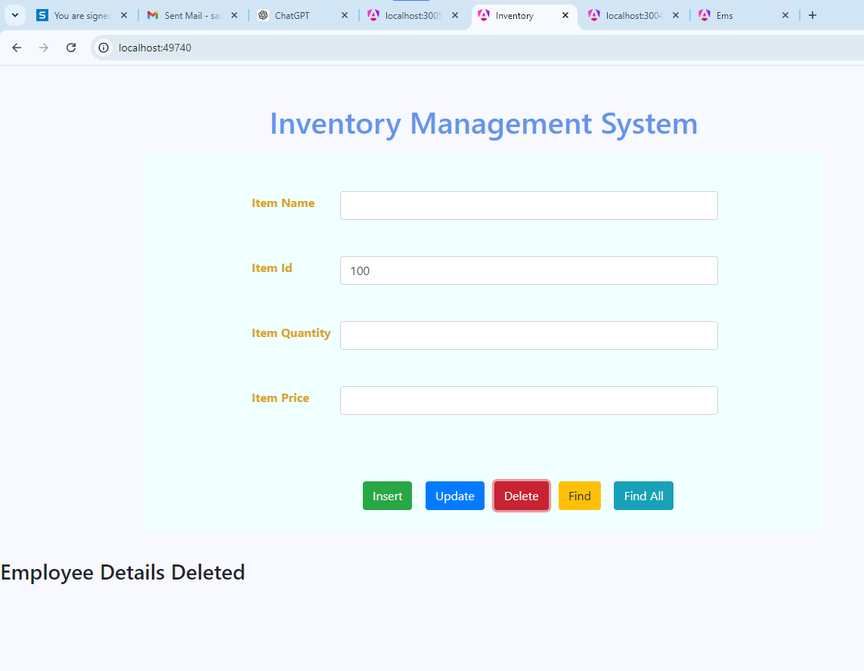

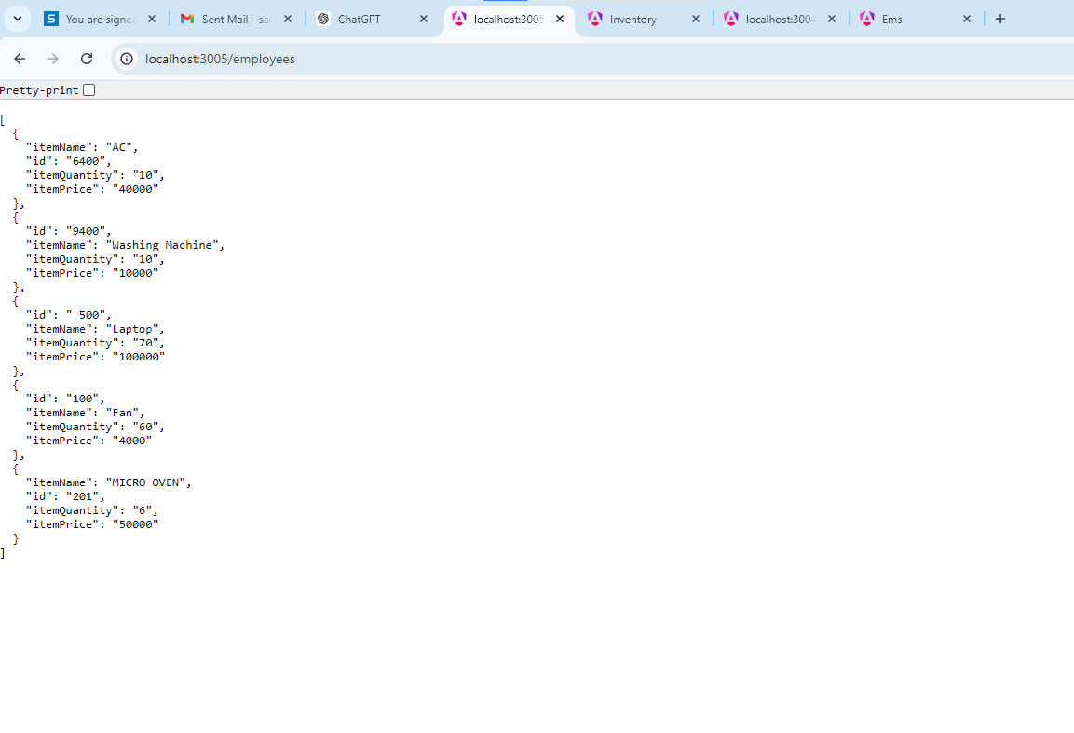

**4. FIND IN INVENTORY MANAGEMENT SYSTEM.**

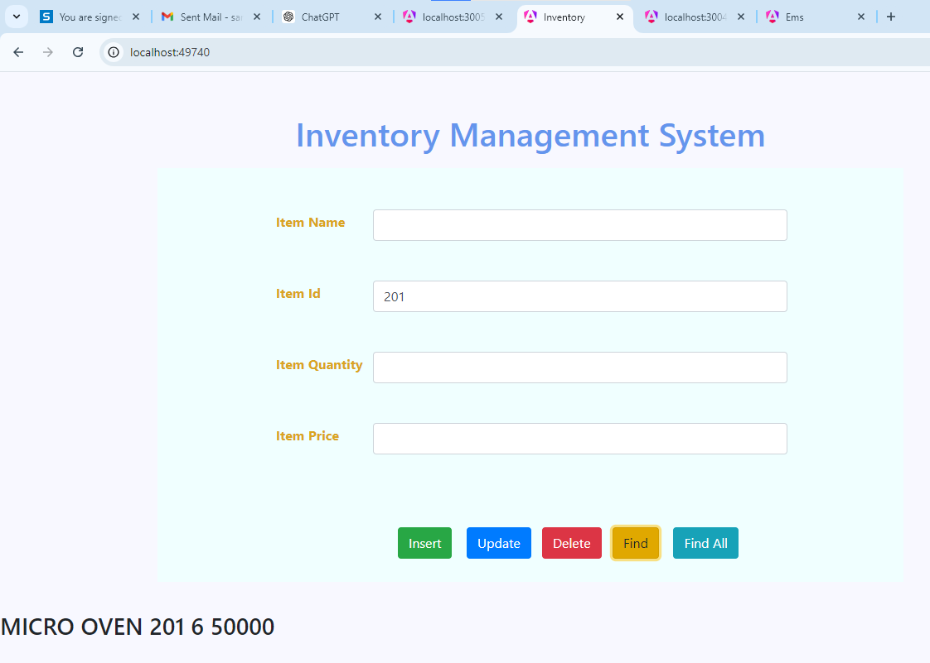

**5 . FINDALL IN INVENTORY MANAGEMENT SYSTEM**

